REGISTER NUMBERS:  19BAI1872  19BAI1016  19BAI1144 | NAME:  YESHWANTH P  AKASH SHIVAKUMAR  VIKRAM G

  PROJECT OBJECTIVES:
  - To assist the Stock Market Investors in analyzing the best company to invest through which they can have a stable profit.
  This process prevents the Investors from investing in a worse company in market and prevent them from facing a loss.
  PROBLEM DEFENITION:
  - We analyse a Database which has a set of companies with their market capital and volume of shares in specific dates.
  - These datas are compared and plotted in neo4j graph based on specific dates.
  - Finally graphs are plotted for both Market Capital and Volume of Shares each.
  - Through the graphs we can infer the best Company to invest in.
  RESULT:
  The Companies that are Best to Invest in are found and also the companies not to invest in are also found out .
  Thus helping the investor to seek profit in his Investments
  CONCLUSION:
  - Thus we have used Neo4j and Cypher querying in Python to analyse the Stock Market and help the Investors.
  IMPORTANT CODE:
  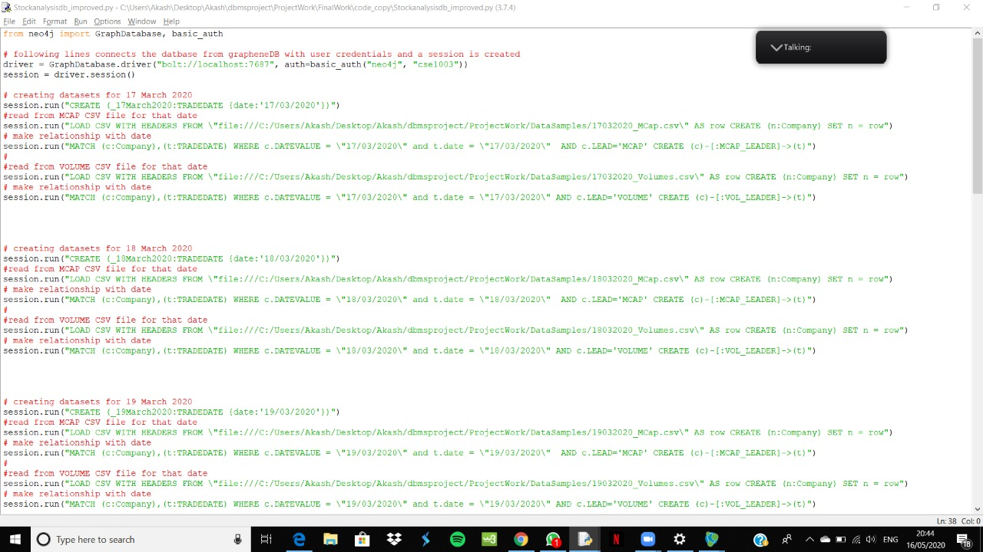
  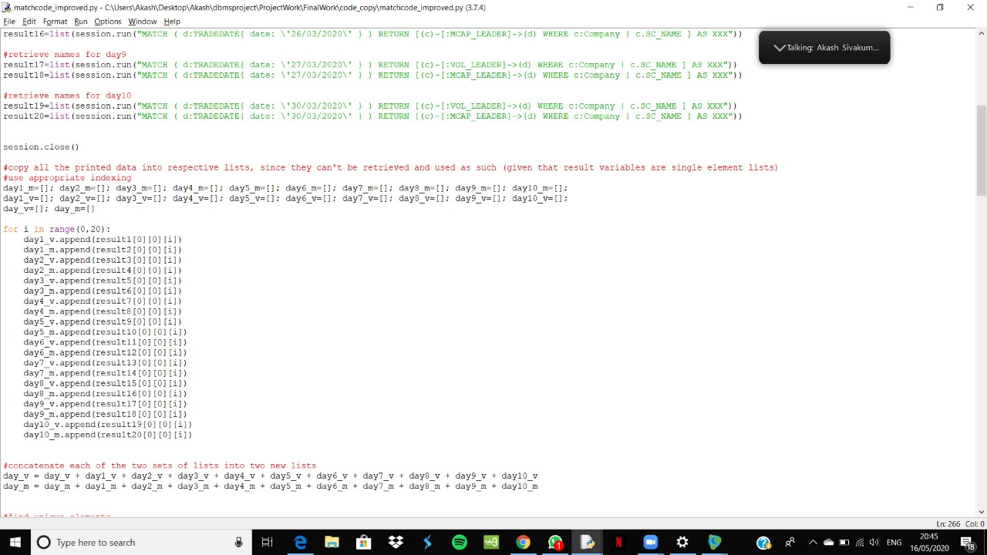
  FLOW CHART:
  